VB.NET Programming (54) Ohio

Regional—2008 KEY
JUDGES SCORING SHEET – NOT TO BE HANDED OUT TO STUDENT

Scoring the form:  - Heading ………………….………………….………………………………  - 2 text boxes for Customer first and last names and descriptive labels..  - 2 group boxes for check boxes and command buttons…………………  - “Select a Type” combo box and descriptive Label ………………………  - 3 Check Boxes ………………………………….………………………….  - 5 Command buttons ………………….………………….…………………  - Invoice list Box (Used to display the Invoice) …………………………...  - Label with “Programmer: contestant number in lower right corner” ….  Scoring the code:  - Define the pass type rates in name constants…………………………..  - Code to load Pass Type Combo Box in the load event………………..  - Text property of the Type Combo Box indicates function <select type> .  - Switch/case structure was used to calculate the rates………………….  - Try/Catch used at least once to catch arithmetic errors in button submit routine ……………………………………………………………..  - Each 6 sub routines documented  - General documentation at top of form class  - Standard prefix naming conventions were used on controls and variables  Scoring the Execution  - The form looks like the test handout of the form………………………..…..  - Controls are all left aligned within their group………………………….…..  - Invoice line 1: Properly formatted last, first …………………………….…..  - Invoice line 2: Correct invoice total updates as lines are entered ………..….  - Invoice line 2: Invoice total is properly formatted……………………….…..  - Invoice line 3: blank ………………………………………………………….  - Invoice line 4: Correct Heading  - Invoice line 5: first item, Junior all available rentals selections. Text ………..  - Invoice line 5: first item, Junior all available rentals selections.Amount ……  - Invoice line 6: second item, Senior, no rental. Text ……………………….…  - Invoice line 6: second item, Senior, no rental. Amount…………….………...  - Invoice line 7: Adult ski rental. Text only …………………………………...  - Invoice line 7: Adult ski rental. Amount ………………………………….….  - Decimals aligned on all 3 lines ………………………………………………  - Clear Item routine (tested on submitted application)……………..…………..  - Clear Invoice routine (tested on submitted application)………….………..…  - New Customer routine (tested on submitted application)…………………….  - Exit routine (tested on submitted application)……………………….……..…  TOTAL APPLICATION POINTS | _____(5)  _____(12)  _____(6)  _____(6)  _____(9)  _____(15)  _____(6)  _____(10) ______(69)  _____(30)  _____(50)  _____(20)  _____(20)  _____(50)  _____(30)  _____(15)  _____(30) ______(245)  _____(30)  _____(20)  _____(30)  _____(100)  _____(25)  _____(10)  _____(15)  _____(30)  _____(25)  _____(18)  _____(25)  _____(12)  _____(25)  _____(12)  _____(40)  _____(20)  _____(20)  _____(10) ______(467)  ______(781)

Screen print with required field entries

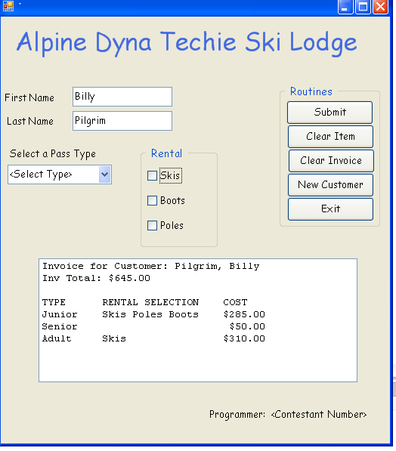

// Project: Purchase Pass, C# Regional Test 2008
// Programmer: ??
// This program ...

using System;
using System.Collections;
using System.Collections.Generic;
using System.Data;
using System.Drawing;
using System.Diagnostics;
using System.Windows.Forms;

namespace prjslnVbNetReg08
{
public partial class frmPurchasePass
{
internal frmPurchasePass()
{
InitializeComponent();
}
// Program constants
private decimal adultRate = 185.0M;
private decimal juniorRate = 75.0M;
private decimal seniorRate = 50.0M;
// Program variables
private decimal invoiceTot = 0M;
private decimal lineTot = 0M;
private bool blnCustOnInv = false;

private void frmPurchasePass_Load(object sender, System.EventArgs e)
// The load event populates the Pass Type comboBox
{
//Load the combobox with pass types
cboPassType.Items.Add("<Select Type>");
cboPassType.Items.Add("Adult");
cboPassType.Items.Add("Junior");
cboPassType.Items.Add("Senior");
cboPassType.SelectedIndex = 0;
}

private void btnSubmit_Click(object sender, System.EventArgs e)
// This routine adds a line to the invoice, calculates the total cost to the customer
// and displays the invoice
{
if (cboPassType.Text == "<Select Type>")
{
MessageBox.Show("Please Select a Type", "Data Detective",
MessageBoxButtons.OK, MessageBoxIcon.Error);
cboPassType.Focus();
return;
}
if (! blnCustOnInv)
{
blnCustOnInv = true;
lstCustInv.Items.Add
("Invoice for Customer: " + txtLastName.Text + ", " + txtFirstName.Text);
lstCustInv.Items.Add(" ");
lstCustInv.Items.Add(" ");
lstCustInv.Items.Add("TYPE RENTAL SELECTION COST");
}

string strLineItem = null;
try
{
strLineItem = cboPassType.Items[cboPassType.SelectedIndex].ToString();
strLineItem = strLineItem.PadRight(10, ' ');
if (chkSkis.Checked)
{
strLineItem += chkSkis.Text + " ";
lineTot += 125.0M;
}
if (chkPoles.Checked)
{
strLineItem += chkPoles.Text + " ";
lineTot += 10.0M;
}
if (chkBoots.Checked)
{
strLineItem += chkBoots.Text + " ";
lineTot += 75.0M;
}

switch (this.cboPassType.Text.ToUpper())
{
case "ADULT":
lineTot += adultRate;
break;
case "JUNIOR":
lineTot += juniorRate;
break;
case "SENIOR":
lineTot += seniorRate;
break;
}
invoiceTot += lineTot;
}
catch (ArithmeticException mathErr)
{
MessageBox.Show("An internal arithmetic error has occurred \n"
+ mathErr.Message, "The Data Detective");
} // end catch

//Add the invoice total to the invoice
lstCustInv.Items.RemoveAt(1);
lstCustInv.Items.Insert(1, "Inv Total: " + invoiceTot.ToString("C"));

//Add the invoice line item to the invoice
strLineItem = strLineItem.PadRight(30, ' ');
strLineItem += Microsoft.VisualBasic.Strings.RSet
(Microsoft.VisualBasic.Strings.FormatCurrency(lineTot, -1,
Microsoft.VisualBasic.TriState.UseDefault,
Microsoft.VisualBasic.TriState.UseDefault,
Microsoft.VisualBasic.TriState.UseDefault), 7);
lstCustInv.Items.Add(strLineItem);

//Reset defaults
cboPassType.SelectedIndex = 0;
chkSkis.Checked = false;
chkPoles.Checked = false;
chkBoots.Checked = false;
lineTot = 0;
}

private void btnClearItem_Click(object sender, System.EventArgs e)
// This clears one item from the invoice item list in the list box
{
if (lstCustInv.SelectedIndex > -1)
{
//Adjust and print the invoice total to the invoice
try
{
decimal dollarAmt;
string strDollarAmt =
((string)(lstCustInv.Text.Substring(lstCustInv.Text.Length - 7)))
.Replace("$", "");
dollarAmt = decimal.Parse(strDollarAmt);
invoiceTot -= dollarAmt;
lstCustInv.Items.RemoveAt(1);
lstCustInv.Items.Insert(1, "Inv Total: " + invoiceTot.ToString("C"));
//Delete the item
lstCustInv.Items.RemoveAt(lstCustInv.SelectedIndex);
}
catch (Exception generalExceptionErr)
{
MessageBox.Show("A general exception error has occurred \n" +
generalExceptionErr.Message, "The Informer");
} // end catch
}
else
{
if (lstCustInv.Items.Count > 0)
{
MessageBox.Show("Please select an item to delete",
"Data Detective", MessageBoxButtons.OK, MessageBoxIcon.Error);
}
else
{
MessageBox.Show("You have nothing in your invoice",
"The Informer", MessageBoxButtons.OK, MessageBoxIcon.Information);
}
} // endIf
}

private void btnNewCust_Click(object sender, System.EventArgs e)
//This routine clears the invoice and starts a new new invoice
{
blnCustOnInv = false;
txtFirstName.Text = "";
txtLastName.Text = "";
cboPassType.SelectedIndex = 0;
chkSkis.Checked = false;
chkPoles.Checked = false;
chkBoots.Checked = false;
invoiceTot = 0;
lstCustInv.Items.Clear();
}

private void btnClearInvoice_Click(object sender, System.EventArgs e)
//This routine clears the invoice, but does not start a new new invoice
{
DialogResult resp = 0;
resp = MessageBox.Show("Are you sure you want to clear your order?",
"The Inquisitor", MessageBoxButtons.YesNo, MessageBoxIcon.Warning,
MessageBoxDefaultButton.Button2);
if (resp == System.Windows.Forms.DialogResult.Yes)
{
lstCustInv.Items.Clear();
}
invoiceTot = 0;
lineTot = 0;
}

private void btnExit_Click_1(object sender, System.EventArgs e)
//This routine exits the application
{
this.Close();
}
}

} //end of root namespace

